**CHAPTER SIX**

This section presents and initial storyboard for the proposed system. Each page was designed to provide the functions of the system. The first iteration is based on the system structure layout.



# **CHAPTER SEVEN**

## 

## **7.0 USER MANUAL**

Click here to signup if you don’t have an account yet

## **7.1 HOME PAGE**

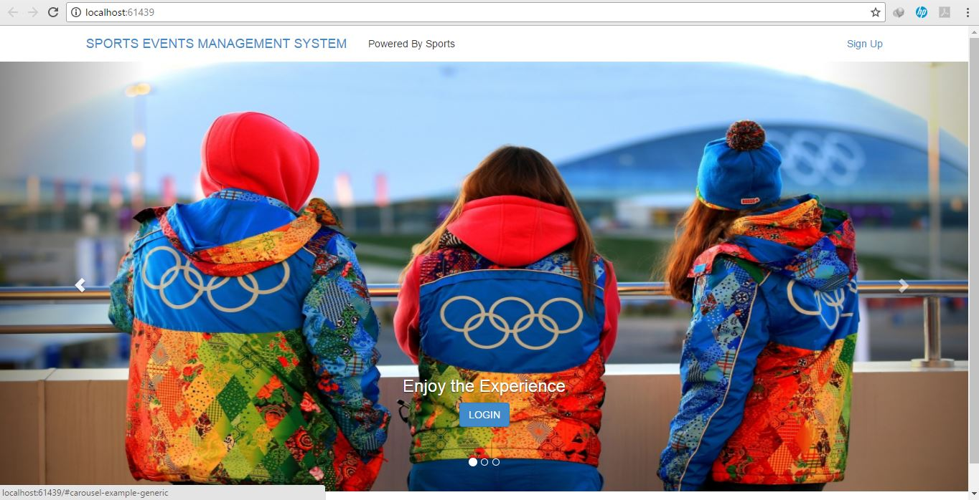

This is the Button you click if you have already Signed Up on the System.

The Picture above shows the overview of the Home Page which displays a series of pictures which pertains to the environment or category the system belongs to.

## 

## **7.2 Sign Up Page**

Click on this Button after you have Signed Up

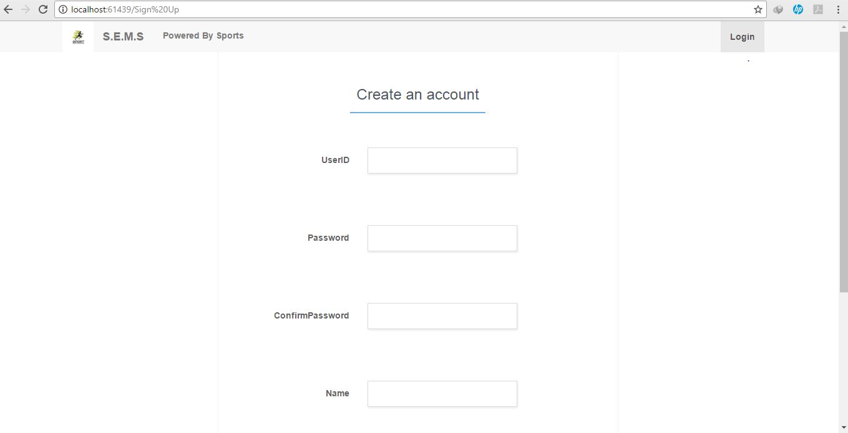

The Picture above shows the overview of the Signup Page which displays enables the user to Sign up on the System for the System to recognize the User Type.

## **7.2 Login Page**

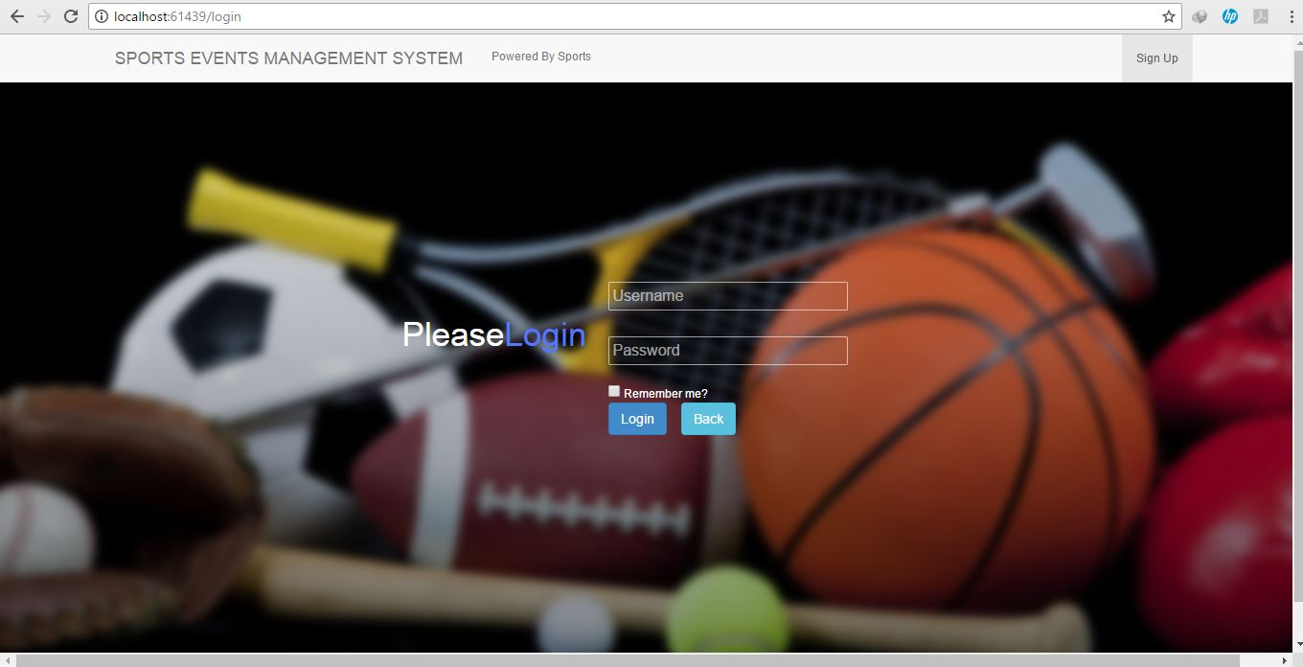

Click here to Login and return page to the homepage

The Picture above shows the overview of the Login Page which Logs the Users to their Particular Page.

## **7.3 Trending Events Page** (Participants/Student)

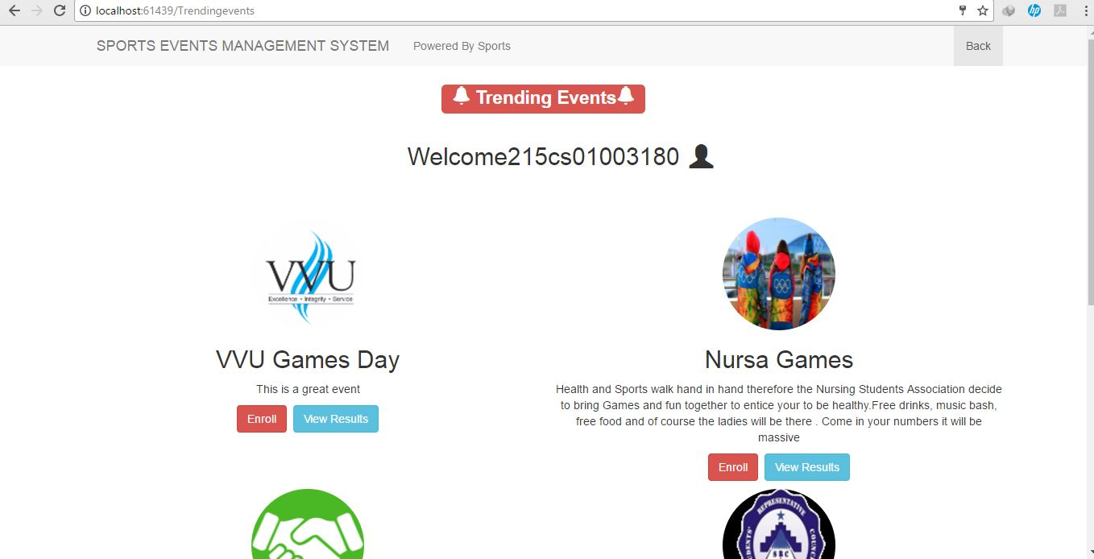

Click Here to View Results

Click Here to Enroll

The Picture above shows the overview of the Trending Events Page which shows the User a list of events with their descriptions.

## **7.4 Participant Enrollment Page** (Participants)

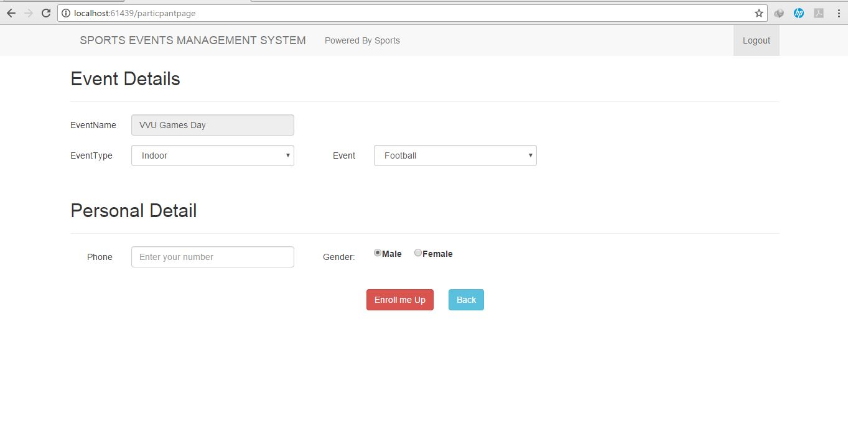

Click Here to Enroll for an Event

The Picture above shows the overview of the Enrollment Page where the User fills in his participation details.

## **7.5 View Results Page** (Participants/Students)

Click Here to Log Out

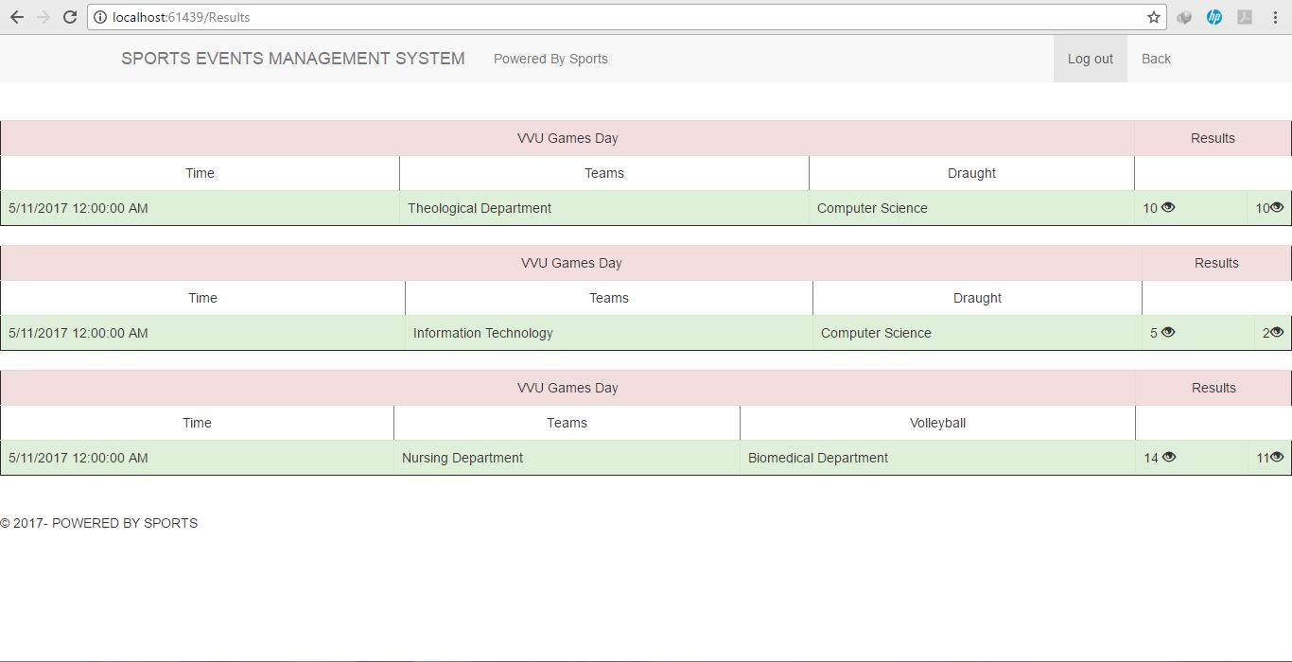

The Picture above shows the overview of the View Results Page where Scores and results of the Events can be viewed.

## **7.6 Supervisor Page**

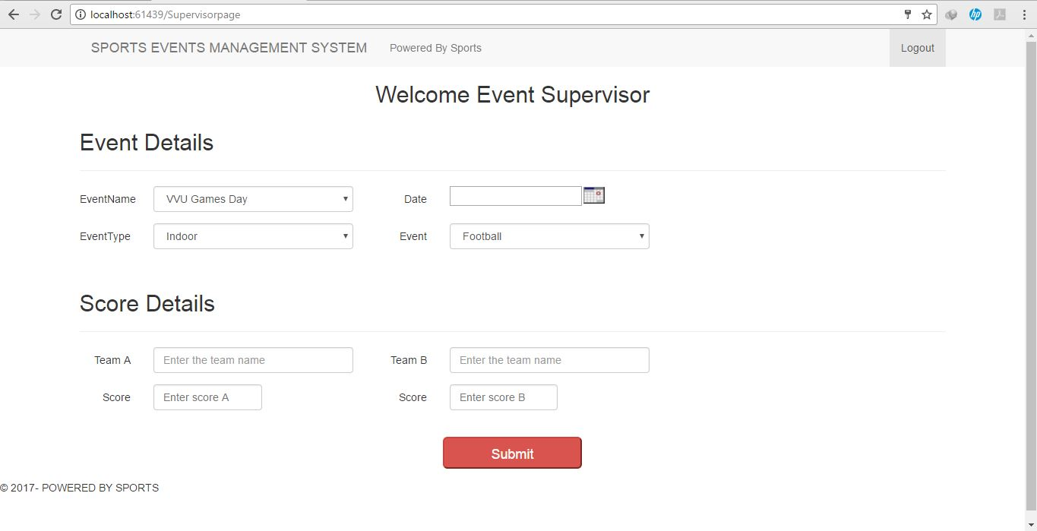

Click Here to Submit Results

The Picture above shows the overview of the Event Supervisor Page where the Names of the Teams are entered and Scores of the outcome of the Events Are Submitted.

## **7.7 Administrator Page**

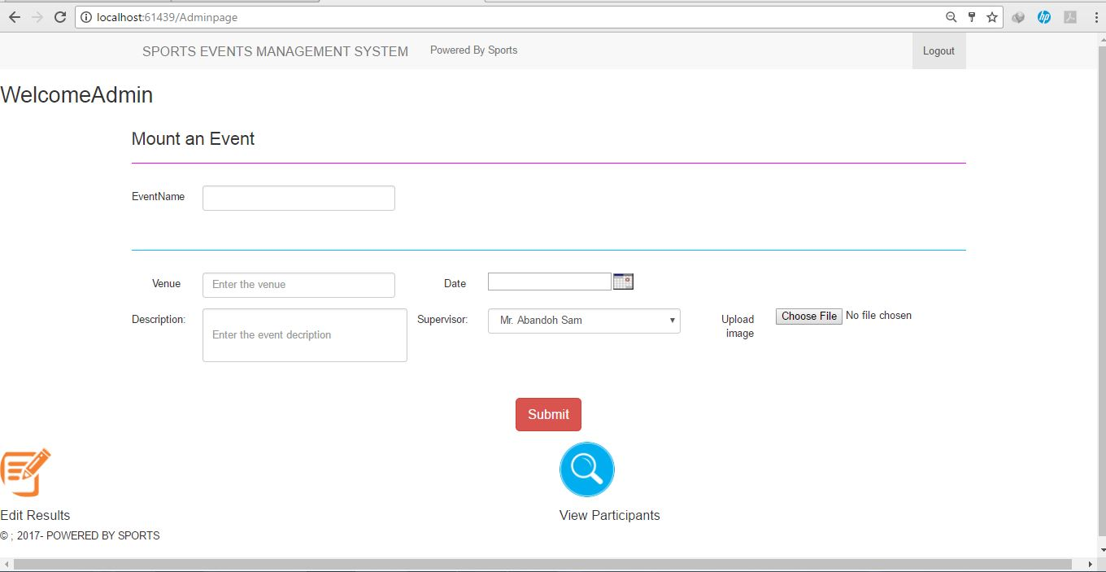

Click Here to make correction to results submitted if there be any error

Click Here to View Participants who enrolled for particular events

Click Here to Mount an Event after details of the Event have been filled

The Picture above shows the overview of the Administrator page and its functions where he mounts the Events, Edits Results, View Participants and lastly downloads and views Reports.

## **7.8 Edit Results Page** (Administrator Page)

Click on the Search Button

Select your Event from the Dropdown List

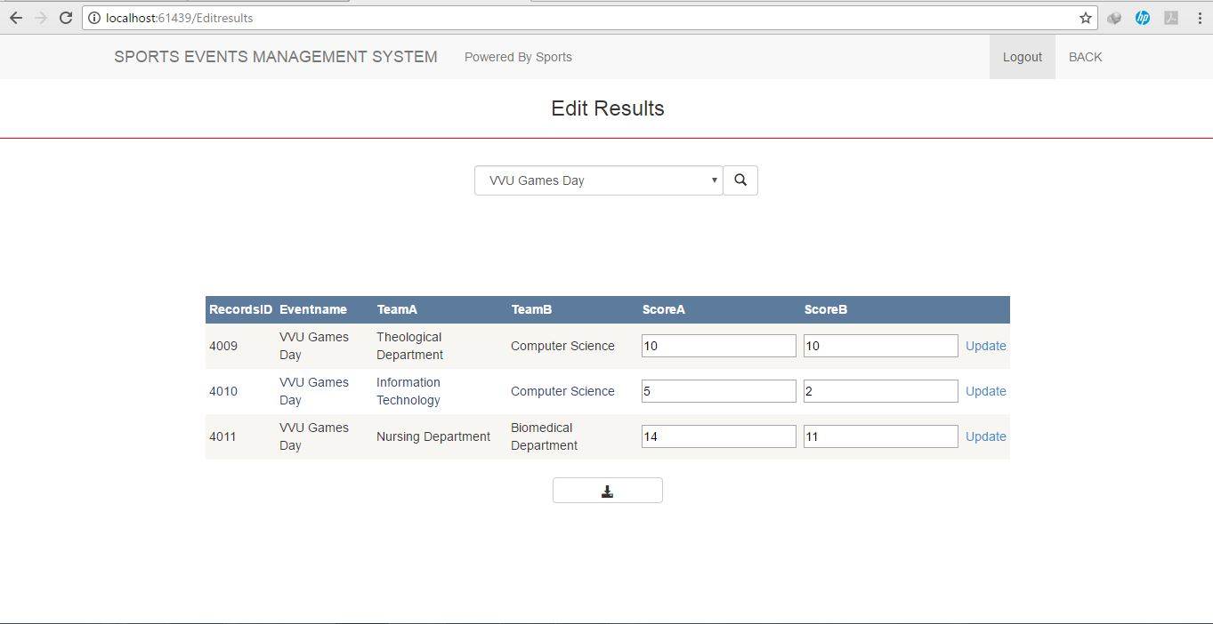

Click on Update Button to update and Modify Results

Edit Results by replacing correct one

Click to View and Download Report

Click on the search button

## **7.9 View Participant Page** (Administrator Page)

Firstly, chose an Event form the dropdown list

Chose from the Radio Button Option

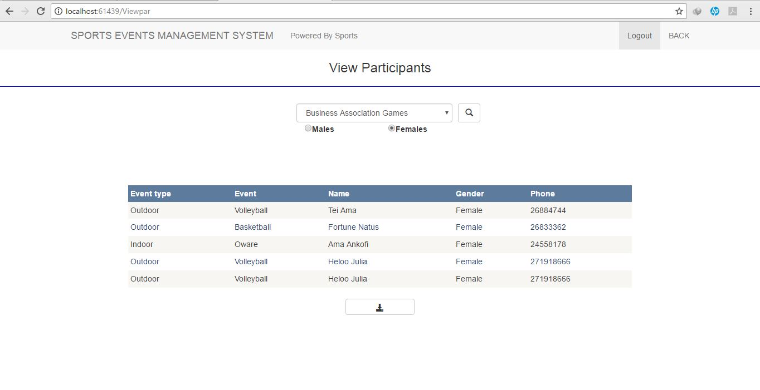

Click to View and Download Report